This task contains screenshots of solutions.

1. Connect to psql using superuser.

Then create user matt with password test valid end of this year.



“postgres” is the default superuser for a PostgreSQL database.

Notice the reticle being a hash, “#”, indicating a superuser, as opposed to

, which indicates that you are not logged in as a superuser.

2. Grant SELECT privilege for salesman table to matt

Grant CREATEUSER role to matt

Then quit the psql and then connect to your database as matt.

As matt find all salesman id and name

As matt try to find all customer names from customer table. What happens and why?



Then logging in as matt:



Then we try to select all the names from the customer table:



This gives an error, since we have only given matt SELECT permission for the “salesman table”, but not the “customer” table.

3. Quit the psql and login as super user

Grant matt SELECT and DELETE privileges to customer and orders

Grant Matt UPDATE privilege to orders table

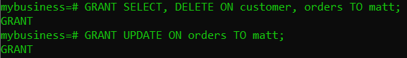

4. As matt

Find all the customers (all columns) from customer table

Update order whose id is 70008 purch_amount to 5800

Create user lisa with password test



5. As matt

Create a group called staff

Add lisa and matt to staff

Why are you able to do all of this as matt?

As superuser Grant staff SELECT, UPDATE and INSERT privileges to all your database tables (salesman, customer, orders)

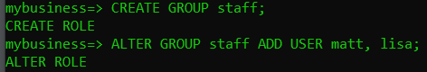

Matt has permission to create roles, thus being able to create groups as well.

6. As lisa Write one SELECT, INSERT and UPDATE SQL command to one of the tables and check if that works. Try to delete the row you inserted before. What happens?

Logging in as lisa:



We didn’t give DELETE permissions to the “staff” group, nor the “lisa” user.

7. Do the same as in the previous task but as matt. Is there any difference compared to what you did as lisa?

Again, switching back to matt:



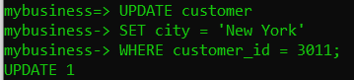

Matt has DELETE permissions, given previously.

8. As superuser drop DELETE privilege from tables customer and orders from Matt. Try out that Matt cannot delete rows anymore. Drop user lisa.

Change of user, yet again:



Changing back to matt:



Then changing back to the superuser, we can drop the user “lisa”:

